Affiliated to Pokhara University
UNITED TECHNICAL COLLEGE

A Minor Project Proposal
on
BLOOD DONATION
[Code No:…….]
(For partial fulfillment of Sixth Semester in Computer Engineering)

Submitted by
Aashish Regmi (22070088)
Ayush Shrestha (22070092)
Dixit Shrestha (22070098)
Sonish Lohani (Roll No.)

Submitted to
Department of Computer Engineering

ABSTRACT
This project aims to create a comprehensive blood donation website to simplify the process of connecting blood donors with recipients and enhance the overall efficiency of the blood donation system. The platform will serve as a centralized hub, enabling seamless interaction between donors, recipients, and organizations while addressing key challenges such as delays in donor-recipient matching, lack of real-time updates, and insufficient donor engagement. The primary goal of the project is to improve access to critical blood supplies, encourage regular donations, and provide a user-friendly solution to overcome current inefficiencies. This initiative is vital as it addresses pressing healthcare needs and promotes a culture of altruism and community involvement. Modern web technologies will be used to develop the website, incorporating features like geolocation-based donor searches, real-time notifications, and secure data management. The implementation will leverage tools such as HTML, CSS, JavaScript, and a backend framework like Node.js or Django, complemented by database systems for efficient data handling. Additionally, APIs for maps and notifications will enhance the platform's functionality, ensuring an intuitive and seamless user experience. The anticipated outcomes include a fully operational, accessible, and secure blood donation website that supports efficient donor-recipient matching, facilitates the organization of donation drives, and engages users with educational resources and timely updates. Ultimately, this project aspires to save lives by improving the accessibility and impact of blood donation while addressing the shortcomings of existing systems.
Keywords: Blood donation website, donor-recipient matching, donor engagement, secure data management, user-friendly, efficient data handling.

Table of Contents
ABSTRACT ii
List of Figures iv
List of Tables v
Acronyms and Abbreviation vi
CHAPTER 1: INTRODUCTION 1
1.1 Background 1
1.2 Problem Statement 2
1.3 Objectives 2
1.4 Motivation and Significance 3
1.5 Scope of the Work 4
CHAPTER 2: LITERATURE REVIEW 5
2.1 Overview of Existing Systems 5
2.2 Comparison of Features 6
2.3 Gaps in Existing Systems 7
2.4 Significance of Proposed Work 9
CHAPTER 3: METHODOLOGY 11
3.1 Overview of the Approach 11
3.2 System or Model Design 17
3.3 Technology Stack 17
3.4 Development Process 19
3.5 Feasibility Study 20
3.6 E-R Diagram 21
3.7 Use Case Diagram 22
CHAPTER 4: EXPECTED OUTCOME 23
CHAPTER 5: CONCLUSION 24
References 25
Appendices A: Gantt chart 26

List of Figures
Figure 3.2.1 Block Diagram of Digital Blood Bank System 17

Figure 3.6 E-R Diagram……. ……………………………………………………….21

Figure 3.7 Use Case Diagram 22

List of Tables
Table 2. 2 Comparison of Features 6

Table A. Gantt chart of the project 26

Acronyms and Abbreviation
AI: Artificial Intelligence
API: Application Programming Interface
AWS: Amazon Web Services
CSS: Cascading Style Sheets
E-R: Entity-Relationship
HTML: Hyper-Text Markup Language
IoT: Internet of Things
NGO: Non-Governmental Organization
SMS: Short Message Service
SQL: Structured Query Language

CHAPTER 1: INTRODUCTION

1.1 Background
Blood donation has always been a vital aspect of healthcare, providing critical support for patients requiring transfusions during surgeries, accidents, or treatments. With the integration of technology into healthcare, new opportunities have emerged to enhance the blood donation process. Tools such as digital platforms, mobile apps, and geolocation systems have helped connect donors, recipients, and blood banks, streamlining donor matching and facilitating donation drives. (Chen & Wang, 2019)
Recent advancements include using Artificial Intelligence (AI) to forecast blood demand, implementing blockchain technology to ensure safe and traceable blood supplies, and leveraging mobile apps to deliver real-time updates on donation events and urgent blood needs. Additionally, geolocation services have made it easier for donors to find nearby centers, while SMS and email notifications have improved donor engagement and participation. (Jones, 2018)
However, challenges persist in the current systems. Many platforms lack intuitive, user-friendly interfaces, making it difficult for users to navigate or find information effectively. Data security and privacy concerns remain unaddressed on some platforms, discouraging potential donors from signing up. Furthermore, the fragmentation of these systems often results in redundant efforts and inefficiencies, as no single platform offers a comprehensive solution for donors, recipients, and organizations. (American Red Cross, 2017)
Developing an improved blood donation website can address these shortcomings. A thoughtfully designed platform can centralize critical information, improve usability, and encourage collaboration among stakeholders. It can also raise awareness about the importance of regular blood donation, ensure the availability of essential blood supplies, and strengthen the overall resilience of the healthcare system. (Jones, 2018)

1.2 Problem Statement
Blood donation is essential for saving lives, yet current systems for connecting donors and recipients face significant obstacles. These challenges contribute to inefficiencies in the blood supply chain, delays in responding to emergencies, and missed opportunities to engage willing donors. The absence of a centralized, user-friendly platform further complicates the process, creating difficulties for donors, recipients, and organizations.
These limitations result in delays, shortages, and lost opportunities to tap into the goodwill of potential donors. A well-designed blood donation website can address these issues by offering a centralized platform with real-time data, secure communication, and user-friendly features. By bridging the gap between donors, recipients, and organizations, this solution can improve access to blood supplies, enhance operational efficiency, and promote a culture of consistent blood donation.

1.3 Objectives
The objectives of this project are as follows:
- To develop a centralized platform that facilitates efficient matching of blood donors with recipients based on factors such as blood type, location, and urgency.
- To raise awareness about the significance of blood donation and motivate regular donor participation through educational resources and engagement features.
- To empower organizations to organize, manage, and promote blood donation drives effectively, while enabling users to easily register and participate.
- To deliver a secure and user-friendly platform that is accessible across various devices, ensuring data privacy and inclusivity for diverse user groups.

1.4 Motivation and Significance
The motivation for developing a blood donation website arises from the vital role blood donation plays in saving lives and the ongoing challenges of ensuring a consistent and timely blood supply. Despite advancements in technology, existing systems often fail to effectively connect donors and recipients, especially in emergencies. Challenges such as fragmented platforms, the absence of real-time updates, low donor engagement, and inadequate data security underscore the need for a more innovative solution. This project was selected as it combines technological advancements with a critical social need, providing an opportunity to address these issues and significantly improve healthcare outcomes.
The proposed website aims to overcome the limitations of current systems by integrating advanced features that streamline donor-recipient connections and enhance the overall user experience. Unlike existing platforms that operate independently or with limited functionality, this website offers a centralized solution, including real-time donor matching, geolocation-based searches, and secure data management. Additionally, features such as educational resources and notifications are designed to boost donor engagement and raise awareness, encouraging consistent participation. The platform places a strong emphasis on data privacy and security, ensuring users' sensitive information is protected—an issue that is often overlooked in other systems.
This project stands out due to its comprehensive approach and user-focused design. While many existing platforms focus on isolated aspects, such as organizing donation drives or registering donors, this website integrates all critical functions into a unified system. Features like real-time updates, an intuitive interface, and accessibility across devices and languages make the platform more inclusive and user-friendly. Moreover, the emphasis on community-building initiatives, such as recognition programs and social sharing, helps foster a culture of altruism and regular blood donation. By addressing the shortcomings of current systems and incorporating innovative features, this project seeks to revolutionize the blood donation process, making it more efficient, accessible, and impactful.

Scope of the Work
This project is designed as a centralized and user-friendly platform to connect blood donors, recipients, and healthcare organizations. Its main objective is to simplify the blood donation process, enhance accessibility, and resolve inefficiencies in the existing system. The platform aims to deliver a holistic solution to ensure a reliable and timely supply of blood for both medical emergencies and regular requirements.

CHAPTER 2: LITERATURE REVIEW

2.1 Overview of Existing Systems
Numerous blood donation websites and platforms have been developed to facilitate connections between donors and recipients. These systems aim to provide easy access to information, improve donor-recipient matching, and promote awareness about blood donation.
    - Blood Donor Connect: Blood Donor Connect is a platform designed to help users locate potential blood donors based on criteria like location and blood type. Its straightforward interface makes it easy to navigate, providing basic functionalities for searching and connecting users, which meet the primary requirements of a blood donation system (Smith, 2015).
    - Red Cross Blood Donation App: This app, developed by the American Red Cross, enables users to schedule blood donation appointments, monitor their donation history, and set reminders for future donations. It provides an organized approach to managing blood donations and is both functional and user-friendly. (American Red Cross, 2017)
    - BloodBanker: BloodBanker is a web-based platform offering an online directory of blood donors. It allows users to search for donors based on location and blood type, with a simple interface for making connections. (Jones, 2018)
    - BloodLink Mobile App: BloodLink is a mobile application designed for emergency blood donation requests, utilizing geolocation technology to match donors and recipients in nearby areas. Its focus on emergencies makes it particularly valuable in critical situations. (Chen & Wang, 2019)
    - SMS-Based Blood Donation System: This system connects donors and recipients via SMS alerts, offering a simple way to communicate blood donation needs. It is particularly useful for users without access to smartphones or internet-based applications. (Thapa & Shrestha, 2010)

Comparison of Features
Table 2. 2 Comparison of Features
Authors | Description | Features | Drawbacks
(Smith, 2015) | A platform for locating blood donors based on location and blood type. | Simple interface, basic search functionality. | No real-time communication or emergency handling capabilities.
(American Red Cross, 2017) | A U.S.-based app for managing blood donation schedules and tracking donation history. | Appointment scheduling, reminders, donation history tracking. | Restricted geographic coverage; lacks real-time donor-recipient matching.
(Jones, 2018) | A web-based directory for blood donors with search capabilities by location and blood type. | Directory-based search, basic functionality. | Outdated interface; not mobile-responsive; lacks real-time notifications for emergencies.
(Chen & Wang, 2019) | A mobile app designed for emergency blood donation requests using geolocation technology. | Geolocation-based matching, emergency handling capabilities. | Limited scalability; no support for large databases or advanced analytics.
(Thapa & Shrestha, 2010) | A basic SMS-based system for connecting donors and recipients through alerts. | Simple SMS alerts; accessible for non-smartphone users. | No mobile app; lacks real-time updates, secure database integration, and modern features.

2.3 Gaps in Existing Systems
The existing systems reviewed provide a range of functionalities for blood donation management. However, each system has significant gaps that limit their overall effectiveness, scalability, and user accessibility. Below are the identified gaps in the systems:
    - Lack of Real-Time Communication and Notifications:
- Most platforms, (such as (Smith, 2015) and (Jones, 2018)), do not offer real-time communication or notification features, which are essential for immediate coordination during emergencies.
- SMS-Based Blood Donation System relies solely on SMS alerts, which are not updated in real time and can cause delays in response.
    - Limited Scalability
- Systems like (Chen & Wang, 2019) face scalability challenges, limiting their ability to handle an increasing number of users or expand to a wider geographic area.
- The lack of robust infrastructure in several systems restricts their capacity to support growing databases or advanced functionalities like analytics.

    - Geographic Restrictions
- The (American Red Cross, 2017) is restricted to the U.S., making it inaccessible to users in other countries, limiting its global utility.
- Other platforms lack global reach due to their focus on local or regional markets without provisions for broader geographic expansion.
    - Outdated or Inadequate Interfaces
- Systems such as (Jones, 2018) use outdated interfaces and are not mobile-responsive, making them inconvenient for modern users who rely heavily on smartphones and tablets.
- Poor user experience can deter adoption and usage, especially among tech-savvy younger donors.
    - Absence of Advanced Features
- Most systems, including (Smith, 2015), lack advanced geolocation technologies that enable dynamic and efficient donor-recipient matching.
- Systems like (Chen & Wang, 2019) and (Thapa & Shrestha, 2010) do not integrate features like analytics for demand prediction or optimization.
    - Inadequate Support for Emergency Handling
- While the (Chen & Wang, 2019) focuses on emergencies, most other platforms lack dedicated tools to prioritize and manage urgent requests effectively.
- Emergency handling requires features such as real-time updates, secure communication channels, and precise geolocation, which are missing in several systems.
    - Limited Database Integration and Security
- Systems like (Thapa & Shrestha, 2010) do not utilize secure databases, making them unreliable for handling sensitive user information.
- Lack of integration with large databases reduces the ability to centralize and streamline operations, impacting efficiency.
    - Lack of Comprehensive Solutions
- Most existing platforms focus on specific aspects of blood donation management (e.g., donor search, appointment scheduling, emergency requests) without offering a comprehensive solution that combines all necessary functionalities into one platform.

2.4 Significance of Proposed Work
The proposed blood donation website seeks to overcome these challenges by incorporating several key features:
    - Instant Communication and Emergency Response: A significant challenge in current systems is the absence of real-time communication and handling of emergencies. The proposed system aims to incorporate real-time notifications for both donors and recipients, ensuring swift responses to urgent requests. Emergency alerts and real-time coordination will allow users to react quickly to blood donation needs, potentially saving lives during critical situations.
    - Enhanced Donor-Recipient Matching: The project will utilize advanced geolocation technology to enhance the accuracy and speed of donor-recipient matching, especially in emergency cases. By factoring in location, blood type, and urgency, the system will facilitate faster and more precise matches, ensuring that donors are connected with recipients in need without unnecessary delays.
    - Global Reach and Scalability: In contrast to existing systems that are regionally limited, this project is designed with scalability in mind. With the use of cloud infrastructure (AWS) and a flexible architecture, the platform will support growth and expansion, making it accessible to users worldwide, regardless of geographic constraints.
    - Improved User Experience: The proposed system will offer a modern, mobile-responsive interface that ensures seamless access across various devices. Its intuitive design and easy navigation will encourage higher donor engagement, simplifying processes like scheduling appointments, finding blood donors, and tracking donations.
    - Data Security and Privacy: Given the growing concerns about data security, the proposed platform will implement secure database management systems. By using MySQL and encryption protocols, the platform will safeguard sensitive user information, ensuring privacy for both donors and recipients.
    - Incorporation of Cutting-Edge Technology: The system will integrate advanced technologies, including Firebase for real-time notifications and analytics, Google Maps API for geolocation services, and Django for robust backend support. These features will facilitate real-time updates, secure data management, and an enhanced user experience, making the platform more efficient compared to older systems.
    - All-Inclusive Solution: Unlike existing systems that focus on individual aspects of blood donation, this project will provide an all-encompassing solution. It will integrate donor search, appointment scheduling, emergency response, and donation history management into a single platform. This unified approach ensures that all users—donors, recipients, and administrators—benefit from a seamless, user-friendly system.

CHAPTER 3: METHODOLOGY
This section describes the methodology applied in designing and implementing the blood donation website. The approach emphasizes systematic planning, leveraging modern tools, and focusing on user-centered design. The website is created to improve accessibility, facilitate real-time donor-recipient interactions, and ensure ease of use.

Overview of the Approach
The project implemented a client-server architecture to facilitate seamless communication between the frontend, backend, and database. The system was tailored to deliver a responsive interface, secure data handling, and real-time interaction capabilities.
Key technologies included HTML, CSS, and Django for building core functionalities, with Firebase enabling real-time notifications. MySQL served as the database for structured data storage, while integrations like Google Maps API enhanced the platform’s functionality. An iterative Agile methodology was followed to incorporate regular feedback and make iterative improvements throughout the development cycle.
    - Requirements Gathering
- Objective:
The primary objective of this phase was to identify and document the essential functional and non-functional requirements to align the system with the needs of users and the project objectives.
- Techniques Used:
  - Literature Review: Researched existing platforms to identify gaps and opportunities for improvement.
  - Stakeholder Consultations: Conducted interviews and discussions with key users, such as administrators and donors, to understand their needs and expectations.
  - Data Analysis: Analyzed survey responses to prioritize user requirements.
- Data Collection:
  - Data Sources: To ensure the Digital Blood Bank System operates effectively, data must be collected from various sources. Each source contributes unique and critical information essential for the system's functionality.
- Blood Banks: Blood banks serve as a primary source of data for the system.
- Inventory Data: This includes details of available blood units, specifying their types (A, B, AB, O), Rh factors (positive or negative), and expiry dates. Tracking these parameters ensures proper management and utilization of blood resources.
- Donation Records: Past donation data, such as donor IDs, dates of donation, and volumes collected, helps in maintaining a historical record and forecasting future supply.
- Recipient Records: Blood banks also store recipient information, including medical requirements, urgency levels, and the affiliated hospitals or clinics. This data is crucial for matching donors with recipients efficiently.
- Hospitals and Clinics: Hospitals and clinics generate dynamic and demand-driven data for the system.
- Demand Data: This data includes requests for specific blood types, quantities, and urgency levels, enabling the system to prioritize supplies.
- Emergency Cases: Logs of critical situations requiring immediate blood supply help ensure that resources are allocated to life-saving cases first.
- Usage Reports: Hospitals provide reports detailing how blood units were utilized, offering insights into consumption patterns and identifying potential areas for improvement.
- Donors: Donors contribute valuable personal and medical information, vital for system functionality.
- Registration Details: Information such as name, contact details, address, blood group, and medical history is collected during donor registration to assess eligibility.
- Donation History: Data on the frequency and volume of donations helps the system track active donors and identify regular contributors.
- Availability Status: Donors provide information on their readiness and willingness to donate, especially during emergencies, enabling the system to create a pool of on-call donors.
- Public Health Departments: Public health departments provide macro-level data for planning and optimization.
- Demographic Data: This includes regional blood group distributions, population health statistics, and data on specific community needs.
- Campaign Data: Records from previous blood donation drives, including participation rates and outcomes, help plan and target future campaigns effectively.

  - Methods of Data Collection: To build a robust database, the system uses a combination of automated, manual, and campaign-based methods to collect data.
- Automated Data Integration
- APIs: By integrating with existing hospital and blood bank management systems, the system can automatically import data in real-time, reducing manual errors and ensuring seamless updates.
- IoT Devices: IoT-enabled sensors in storage units can monitor inventory levels, track expiry dates, and ensure optimal storage conditions, providing real-time updates to the system.
- Surveys and Forms
- Online Registration: Donors can register through web forms or mobile apps, providing details such as blood type, contact information, and donation history.
- Feedback Surveys: Hospitals, donors, and recipients can submit feedback on system usability and suggest areas for improvement.
- Manual Data Entry
- Field Data Collection: Trained personnel can visit blood banks, hospitals, and clinics to digitize records from locations without digital systems.
- Bulk Upload: Administrators can upload large datasets, such as historical inventory and donor information, using tools that support formats like CSV and Excel files.
- Campaigns and Drives
- Blood Donation Drives: Data collected during organized drives, such as new donor registrations and collected blood types, helps expand the database.
- NGO Collaboration: Partnering with community organizations allows access to their donor networks and supports data collection during local initiatives.
- Public Databases: Publicly available data from government agencies and healthcare organizations can supplement the system, providing insights into demographic trends and blood group distributions.

  - Data Preprocessing: Once data is collected, preprocessing is essential to ensure its quality, consistency, and security.
- Validation: Validation involves verifying the accuracy of collected data. Donor information, such as medical history and blood type, is cross-checked with existing records to minimize errors and ensure reliability.
- De-duplication: Duplicate entries, such as multiple registrations of the same donor or repeated inventory records, are identified and removed to maintain a clean database.
- Normalization: Normalization standardizes the data format across all entries:
- Dates are formatted uniformly (e.g., YYYY-MM-DD).
- Blood group types are represented consistently (e.g., A+ or A-).
- Volume measurements and other numerical data are standardized for easier processing and analysis.
- Encryption: Sensitive personal and medical data is encrypted to protect it from unauthorized access. Role-based access control ensures only authorized users can access specific types of data, enhancing privacy and security.
- Integration: Validated and processed data is integrated into the central system, ensuring compatibility with its structure. This step ensures the system operates seamlessly and provides accurate information to users.
- Tools:
  - Google Forms: Collected survey responses and insights from potential users.
  - Notion: Documented and organized requirements systematically.
  - Spreadsheets: Processed and analyzed survey data to identify trends and key needs.

System or Model Design
    - Overall Framework: The system followed a client-server model, where the frontend handled user interactions, while the backend managed core logic, API operations, and database processes.
Figure 3.2.1 Block Diagram of Digital Blood Bank System
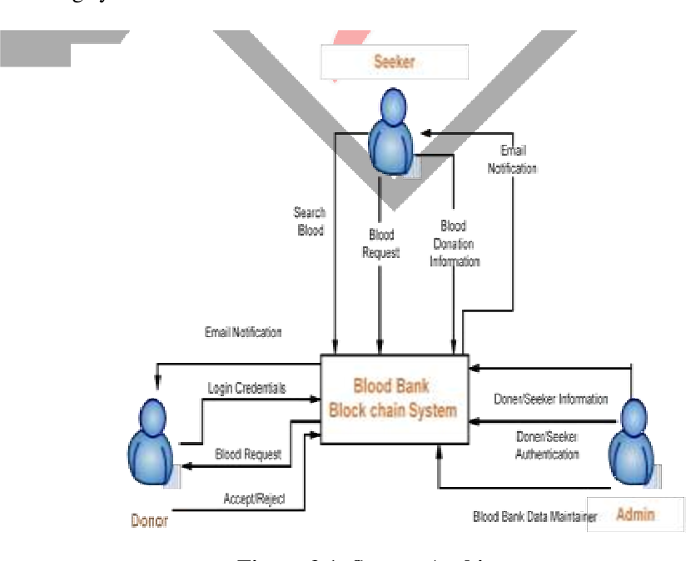

Technology Stack
    - Primary Technologies:
  - Frontend:
    - HTML provides the structural groundwork by arranging content into sections like donor registration forms, blood request submissions, and donor listings, utilizing elements such as forms, tables, and buttons.
    - CSS improves the website's aesthetics and usability by adding styles, including colors, fonts, layouts, and responsive design, ensuring it appears polished and performs efficiently across different devices. Combined, they deliver a visually appealing, easy-to-use platform tailored for donors, recipients, and administrators.
  - Backend:
    - Django, a Python-based framework, is utilized to manage backend operations, including user authentication, handling donor and recipient data, and ensuring secure interactions with the MySQL database. It offers a strong foundation for developing a scalable and maintainable platform.
    - Firebase complements this by providing real-time notifications, delivering instant alerts to donors and recipients during emergencies or important updates.
- Infrastructure:
    - AWS (Amazon Web Services): Powers the website by offering scalable cloud-based solutions for hosting, data storage, and managing applications. It ensures the website is fast, reliable, and can scale as the user base increases, while also providing strong security measures to protect user data.
    - Docker: Docker is utilized to establish consistent and isolated environments for development, testing, and deployment. By containerizing the application's components, it ensures that the platform operates smoothly across various systems, from development to production.
- Data Management:
    - MySQL serves as the core database management system, facilitating the efficient storage, organization, and retrieval of critical data. It handles key information, including donor profiles, recipient requests, blood types, and donation histories.
- External Integrations:
    - Google Maps API: The Google Maps API is integrated into the website to offer geolocation services, helping users easily locate nearby blood donors or donation centers. This feature allows the platform to display interactive maps, enabling recipients to search for available donors within a particular area based on their current location. By facilitating efficient matching of donors and recipients, especially in emergencies, it enhances response times and improves the user experience, making it simpler to connect with nearby donors.
    - Firebase Notifications: Firebase notifications are used to provide real-time alerts and updates to users. When urgent blood donation requests or updates occur, Firebase sends instant push notifications to both donors and recipients, ensuring they are promptly informed.

Development Process
    - Approach: An Agile development methodology was adopted to ensure iterative progress and continuous feedback. This enabled the team to adapt to changes and deliver a functional, user-oriented product within the project timeframe. Key stages included:
- Planning: Defined sprint goals, prioritized tasks, and created a backlog.
- Development: Built features incrementally, focusing on functionality and usability.
- Testing: Conducted thorough testing after each sprint to identify and fix bugs.
- Review: Regularly reviewed progress with stakeholders and incorporated feedback.
    - Version Control:
- Git: Managed code versions and tracked changes efficiently.
- GitHub: Hosted the repository for collaboration, pull request management, and issue tracking.
    - Collaboration and Task Management:
  - Trello: Organized tasks, assigned responsibilities, and monitored progress.
  - GitHub Projects: Used for issue tracking and managing sprint workflows.

Feasibility Study
    - Technical Feasibility: The chosen technology stack, including Django, HTML, CSS, Firebase, and MySQL, was selected for its reliability, scalability, and strong community support. External integrations like Google Maps API and Firebase Notifications provided additional features without adding unnecessary complexity.
    - Economic Feasibility: The project utilized cost-effective tools and resources, such as free-tier services for Django and Firebase during development. Hosting on AWS ensured affordability while maintaining scalability.
    - Operational Feasibility: The system was designed to be intuitive, secure, and capable of handling real-time data efficiently. Its responsive design and robust backend ensured accessibility for a diverse user base.
    - Schedule Feasibility: The project adhered to a structured timeline, with milestones for requirements gathering, system design, development, and testing. The use of Agile ensured the team stayed on track and made adjustments as needed.

E-R Diagram
An Entity-Relationship (ER) diagram illustrates the database structure of a system, highlighting entities, their attributes, and the relationships connecting them. For the blood donation website, the ER diagram depicts the key entities (such as Donor, Patient, Blood Bank, Hospital) and how they interact with one another.
Figure 3.6 E-R Diagram
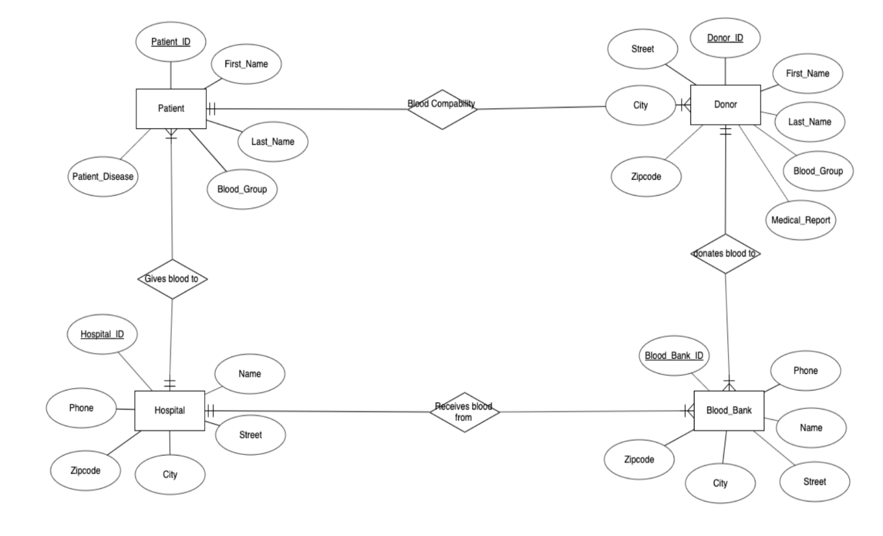

Use Case Diagram
A use case diagram for the blood donation website visually represents the interactions between users and the system, showing the functionalities available to users and how they interact with the platform. The use case diagram helps illustrate the primary interactions between the users and the blood donation system, showcasing its core functionalities. By defining roles and actions, it ensures clarity in system requirements and helps guide development.
Figure 3.7 Use Case Diagram

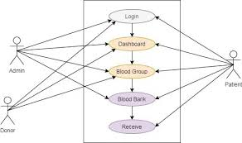

CHAPTER 4: EXPECTED OUTCOME
The website aims to provide a responsive and user-friendly platform that improves accessibility and facilitates seamless interactions for all users, including administrators, donors, and recipients. By utilizing MySQL for secure data storage and management, the system will protect user information and ensure consistent performance. Real-time notifications, enabled through Firebase, will keep users informed of important updates and activities, while the integration of Google Maps API will deliver effective location-based services for managing resources and connections. Hosted on AWS, the platform will offer high scalability and reliability to meet the demands of an expanding user base. Built with Django, its modular structure will allow for easy maintenance and the addition of future features. Overall, the website is designed to optimize processes, boost efficiency, and provide a secure, scalable, and user-focused experience.

CHAPTER 5: CONCLUSION
This project demonstrates a well-rounded approach to developing a user-focused website designed for efficient blood donation management. By utilizing modern technologies such as Django, Firebase, and Google Maps API, the platform ensures smooth user interactions, secure data management, and real-time updates. Hosted on AWS, the system’s scalable infrastructure and modular architecture make it flexible for future enhancements and capable of meeting increasing user demands.
Following an Agile development process allowed for continuous incorporation of user feedback, ensuring the solution meets both functional and non-functional needs. The platform prioritizes accessibility, reliability, and scalability, effectively addressing limitations found in traditional systems. It provides an efficient and user-friendly solution for donors, recipients, and administrators.
In conclusion, this project successfully combines technological innovation with social impact, delivering a platform that not only meets technical requirements but also plays a crucial role in improving blood donation processes, saving lives, and strengthening community connections.

References
American Red Cross. (2017). Retrieved from redcross: https://www.redcross.org/
Chen, L., & Wang, Y. (2019). BloodLink Mobile App: Geolocation-based Blood Donation for Emergency Requests. nternational Journal of Mobile Computing and Communications.
Jones, R. (2018). BloodBanker: A Web-Based Platform for Blood Donor Matching. Journal of Health Informatics.
Smith, D. (2015). Retrieved from Blood Donor Connect: https://thebloodconnection.org/
Thapa, R., & Shrestha, S. (2010). SMS-Based Blood Donation System. International Journal of Computer Science and Technology.

Appendices A: Gantt chart
Before getting started with any work, proper preparation of working schedule containing of all the task that should be done for completion of project is necessary. For this purpose, we have included Gantt chart with time estimation in a total span of 2-3 months is included below.
Table A. Gantt chart of the project
